MET CS 555 Assignment 5
Joseph Rissman
11/26/2024
- How many students are in each group? Summarize the data relating to both test score and age by the student group (separately). Use appropriate numerical and/or graphical summaries.
Statistic | Chemistry Students IQ | Chemistry Students Age
Count | 15 | 15
Minimum | 40 | 32
1st Quartile | 44 | 38
Median | 46 | 41
Mean | 46.27 | 40.07
3rd Quartile | 48 | 43
Maximum | 52 | 46

Statistic | Math Students IQ | Math Students Age
Count | 15 | 15
Minimum | 24 | 16
1st Quartile | 36 | 19
Median | 38 | 20
Mean | 37.6 | 20.73
3rd Quartile | 40.5 | 22.5
Maximum | 45 | 28

Statistic | Physics Students IQ | Physics Students Age
Count | 15 | 15
Minimum | 25 | 14
1st Quartile | 31.5 | 16
Median | 34 | 17
Mean | 34.13 | 17.13
3rd Quartile | 37.5 | 18.5
Maximum | 42 | 20

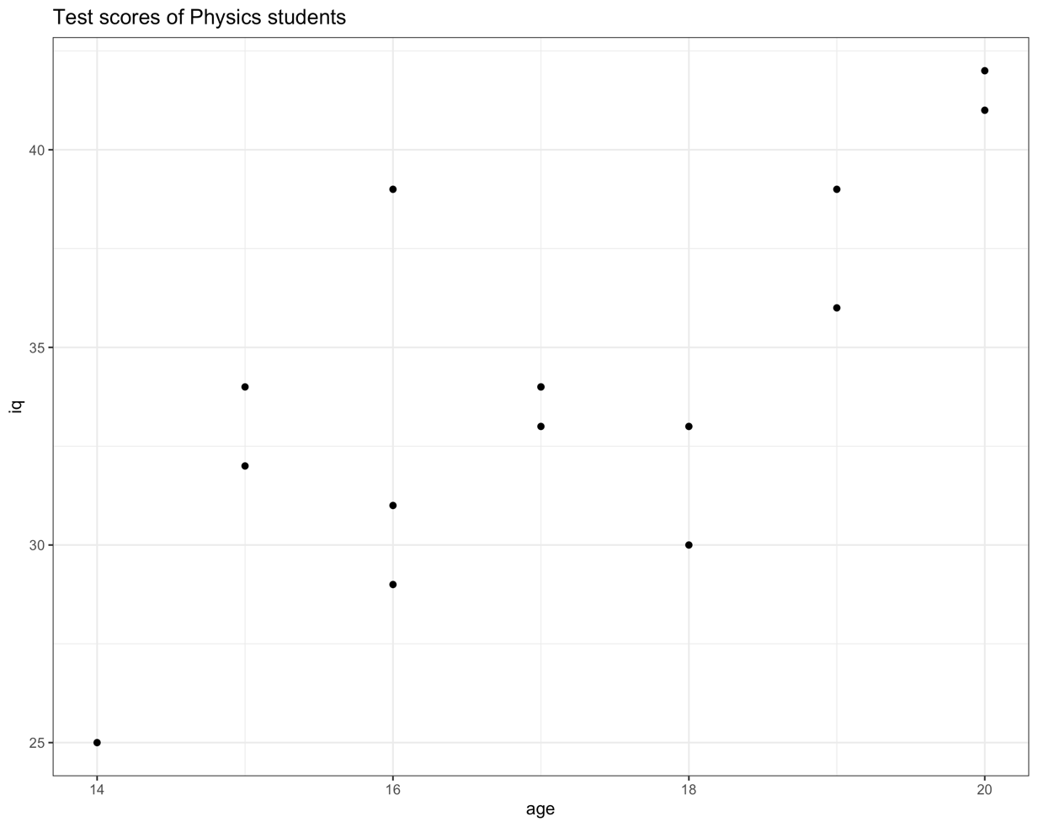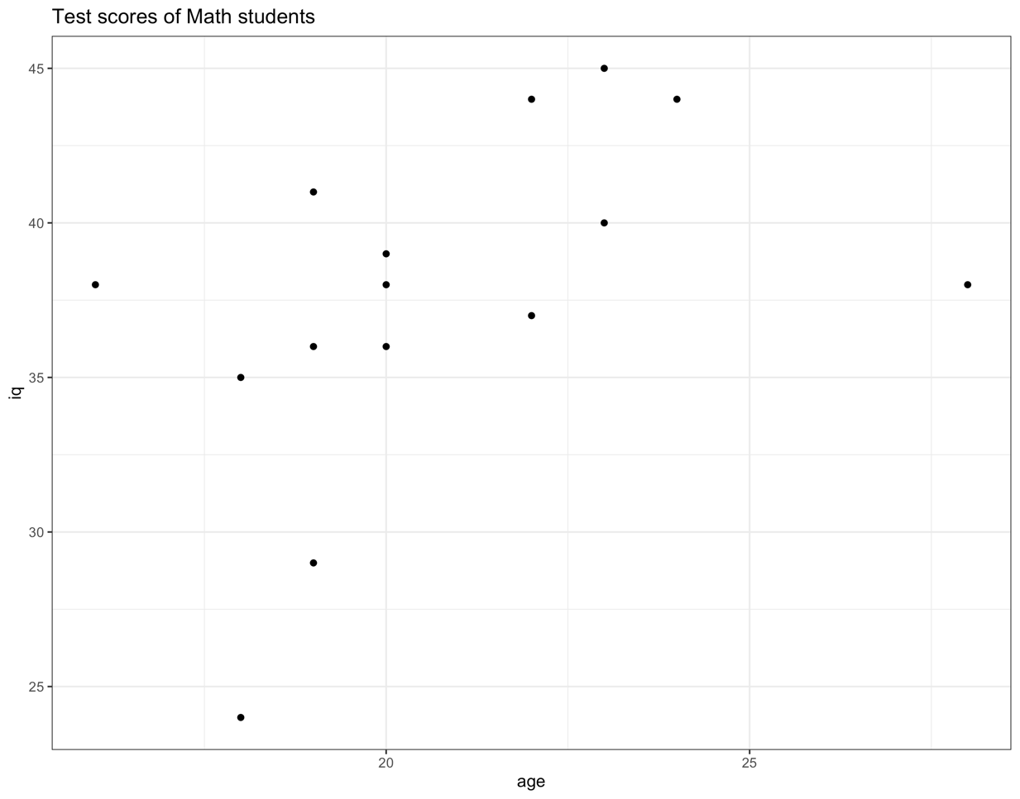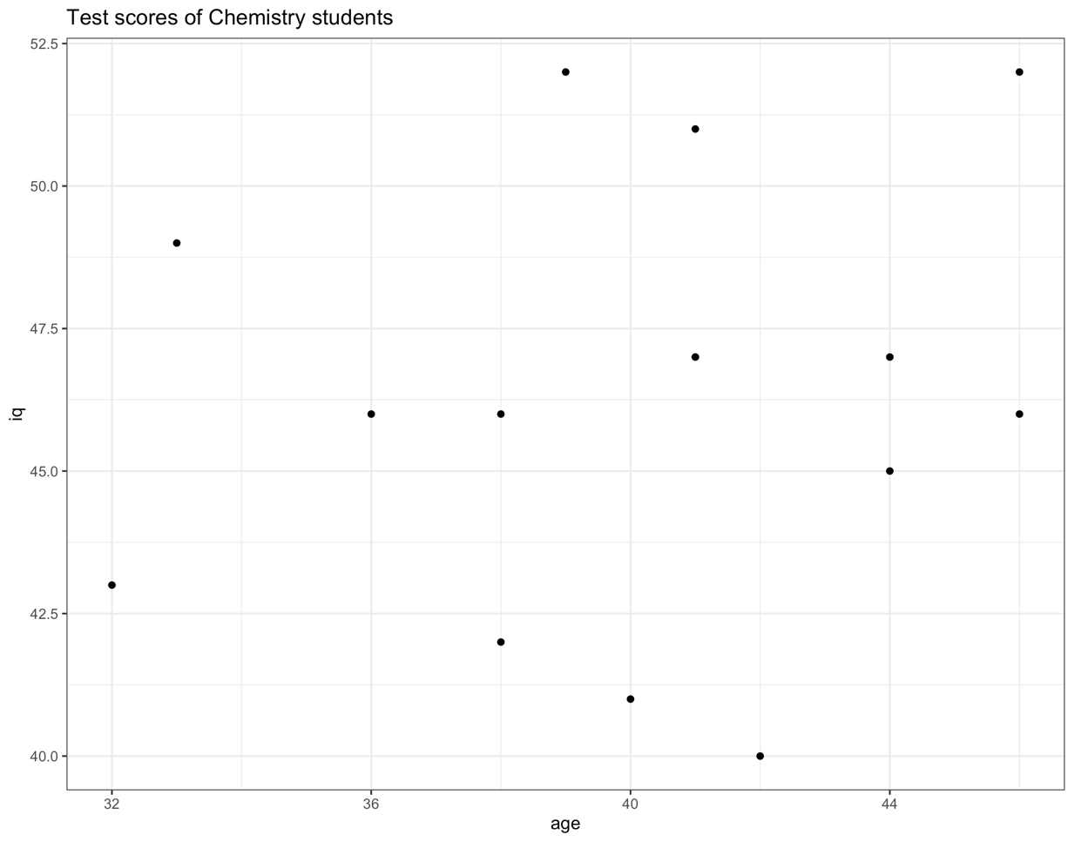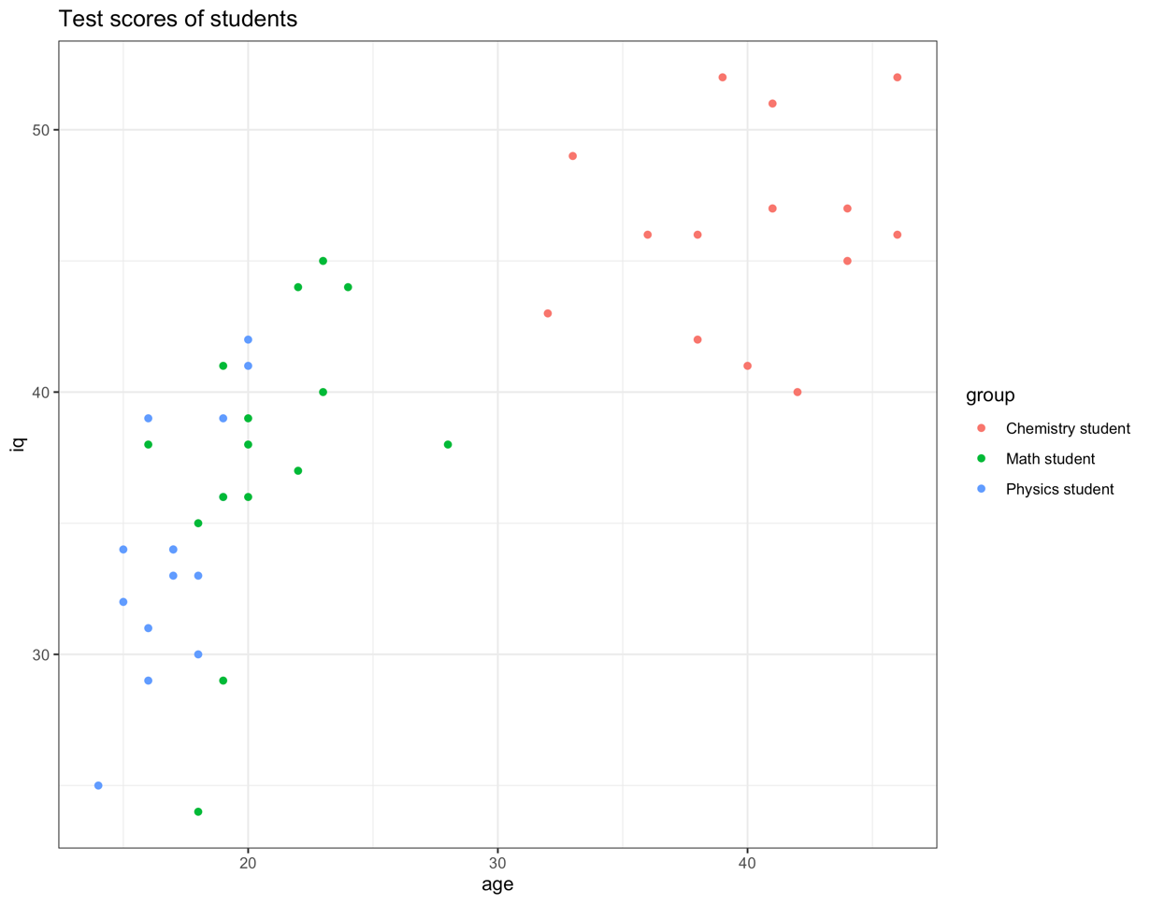
- Do the test scores vary by student group? Perform a one-way ANOVA using the aov or Anova function in R to assess. Use a significance level of $α=0.05$. Summarize the results using the 5-step procedure.
  - Set up the hypotheses and select the alpha level.
$$H_{0}⋮μ_{chemistry}=μ_{math}=μ_{physics}$$
(All underlying population means are equal)
$$H_{1}⋮μ_{i}≠μ_{j} \text{for some }i\text{ and }j\text{.}$$
(Not all of the underlying population means are equal)
$$α=0.05$$
  - Select the appropriate test statistic.
$$F=\frac{\text{MSB}}{\text{MSW}}\text{ with }k-1=2\text{ and }n-k=45-3=42\text{ degrees of freedom}$$
  - State the decision rule.
F-distribution with 2, 42 degrees of freedom and associated with $α=0.05$.
Decision Rule: Reject $H_{0}$ if $F ≥3.220$
Otherwise, do not reject $H_{0}$
  - Compute the test statistic.
$$F=\frac{\text{MSB}}{\text{MSW}}=\frac{585.87}{22.05}=26.565$$
  - Conclusion.
Reject $H_{0}$ since $26.565≥3.220$.
We have significant evidence at the $α=0.05$ level that there is a difference in IQ test scores among chemistry students, math students, and physics students.
If the results of the overall model are significant, perform the appropriate pairwise comparisons using Tukey’s procedure to adjust for multiple comparisons and summarize these results.
Using Tukey Honest Significant Differences to test the pairwise comparisons gives the following results:
 | Difference in Means | Lower Endpoint | Upper Endpoint | Adjusted p-value
Math-Chemistry Students | -8.666667 | -12.832756 | -4.5005778 | 0.0000262
Physics-Chemistry Students | -12.133333 | -16.299422 | -7.9672445 | 0.0000000
Physics-Math Students | -3.466667 | -7.632756 | 0.6994222 | 0.1194835
The results of the pairwise comparisons indicate we have significant evidence at the $α=0.05$ level that there is a difference in IQ test scores among chemistry students and math students, chemistry students and physics students, but not physics and math students. We do not have sufficient evidence to reject the null hypothesis that there is a difference between the IQ test scores of physics and math students at the $α=0.05$ level.
- Create an appropriate number of dummy variables for student group and re-run the one-way ANOVA using the lm function with the newly created dummy variables. Set chemistry students as the reference group.
The results of the multiple linear regression with dummy variables is as follows:
 | Estimate $\hat{β}$ | Standard Error | t-value | Probability >|t|
Physics Students | -12.133 | 1.715 | -7.076 | 1.13e-08
Math Students | -8.667 | 1.715 | -5.054 | 8.93e-06
F-statistic: | 26.57 | p-value: | 3.496e-08
Confirm the results are the same (specifically point out test statistics, p-values, etc. that show the results are equivalent).
The results are the same, because the beta estimates match the difference in group means calculated with the pairwise comparisons. Additionally, the F-statistic calculated with the linear regression model is the same as the F-statistic calculated with the one-way ANOVA. Finally, the p-value of the linear regression model is the same as the probability of seeing >F in the one-way ANOVA. This confirms the results are the same.
What is the interpretation of the beta estimates from the regression model?
The interpretation of the beta estimates from the regression model is the same as the difference in means of the ANOVA model. These values represent the estimate of the difference in IQ test scores between groups. For example, a physics student is estimates to score 12.133 points less than a chemistry student, on average. Likewise, a math student will score 8.667 points less than a chemistry student, on average.

- Re-do the one-way ANOVA adjusting for age (ANCOVA).
 | Sum of Squares | Degrees of Freedom | F-value | Probability >F
Intercept | 152.74 | 1 | 7.8294 | 0.007797
Group (student type) | 21.89 | 2 | 0.5610 | 0.574969
Age | 126.42 | 1 | 6.4804 | 0.014763
Residuals | 799.84 | 41
Focus on the output relating to the comparisons of test score by student type. Explain how this analysis differs from the analysis in step 2 above (not the results but how does this analysis differ in terms of the questions it answers as opposed to the one above).
The ANCOVA analysis is different from the previous analysis because the effect of covariates is controlled for in the ANOVA analysis. The ANCOVA analysis uses a linear regression model to remove the variance explained by the covariates. The covariate in this case is age. By controlling for the effect of age on IQ test score, the ANCOVA model is better able to explain the variance caused by group membership.
Did you obtain different results? Summarize briefly (no need to go through the 5 –step procedure here).
The results are different because the ANCOVA model controls for the effect of age on the IQ test scores. After removing covariate effects, the difference between groups of students is not significant at the $α=0.05$ level. We do not have sufficient evidence to reject the null hypothesis.
Lastly, present the least square means and interpret these.
 | Least-Squares Mean | Standard Error | Degrees of Freedom | Lower 95% Confidence Level | Upper 95% Confidence Level
Chemistry Students | 38.6 | 3.24 | 41 | 32.0 | 45.1
Math Students | 40.5 | 1.60 | 41 | 37.2 | 43.7
Physics Students | 39.0 | 2.22 | 41 | 34.5 | 43.5
The least-squares mean is the mean value of each group after accounting for the effect of the covariate. The LS means for each group of students is very similar and the 95% confidence interval for each group greatly overlaps. This further supports the conclusion that there is not a significant difference between the IQ test scores of the different groups of students after controlling for the effect of age.

R code for Assignment 5
# CS555 Homework Assignment 5
# Load necessary libraries ------------------------------------------------

library(readxl)
library(dplyr)
library(tidyr)
library(purrr)
library(ggplot2)
library(car)
library(emmeans)

# Import and clean data ---------------------------------------------------

data = read_excel("Homework 5/Homework 5 Data.xlsx", col_names = TRUE)
df = tibble(data) %>% group_by(group)

# Problem 1 ---------------------------------------------------------------
# Summarize the data relating to both test score and age by the student group (separately).
# Use appropriate numerical and/or graphical summaries.

# Generate summary statistics for each group
df %>% split(.$group) %>% map(summary)

# Generate a scatter plot for each student group separately
scatter = function(data) {
gg <- ggplot(data, aes(x = age, y = iq)) +
geom_point() +
labs(
title = paste0("Test scores of ",data$group,"s")
) +
theme_bw()
plot(gg)
ggsave(paste0("Homework 5/",group_keys(data)[[1]],"_scatter.png"))

}
for (group in df %>% split(.$group)) {
scatter(group)
}

# Generate a scatter plot for all student groups
gg <- ggplot(df, aes(x = age, y = iq, colour = group)) +
geom_point() +
labs(
title = paste0("Test scores of students")
) +
theme_bw()
plot(gg)
ggsave(paste0("Homework 5/combined_scatter.png"))

# Problem 2 ---------------------------------------------------------------

# Perform a one way ANOVA using the aov or Anova function in R to assess test scores by student group.
# Use a significance level of α=0.05.
anova_model = aov(iq ~ group, df)
summary(anova_model)

# Calculate the critical F-score.
qf(0.95,2,42)

# Perform the appropriate pairwise comparisons using Tukey’s procedure to adjust for multiple comparisons.
TukeyHSD(anova_model)

# Problem 3 ---------------------------------------------------------------

# Create an appropriate number of dummy variables for student group.
# Set chemistry students as the reference group.
df$chemistry = ifelse(df$group == "Chemistry student", 1, 0) # Reference group, not used in analysis.
df$physics = ifelse(df$group == "Physics student", 1, 0)
df$math = ifelse(df$group == "Math student", 1, 0)

# Re-run the one-way ANOVA using the lm function with the newly created dummy variables.
mlr_model <- lm(iq ~ physics + math, df)
summary(mlr_model)

# Problem 4 ---------------------------------------------------------------

# Re-do the one-way ANOVA adjusting for age (ANCOVA).
ancova_model = lm(iq ~ group + age, df)
Anova(ancova_model, type = 3)

# Calcualte least square means.
emm_options(contrasts = c("contr.treatment", "contr.poly"))
emmeans(ancova_model, specs = "group")

